**Mid-Century Modern Wall Shelf**

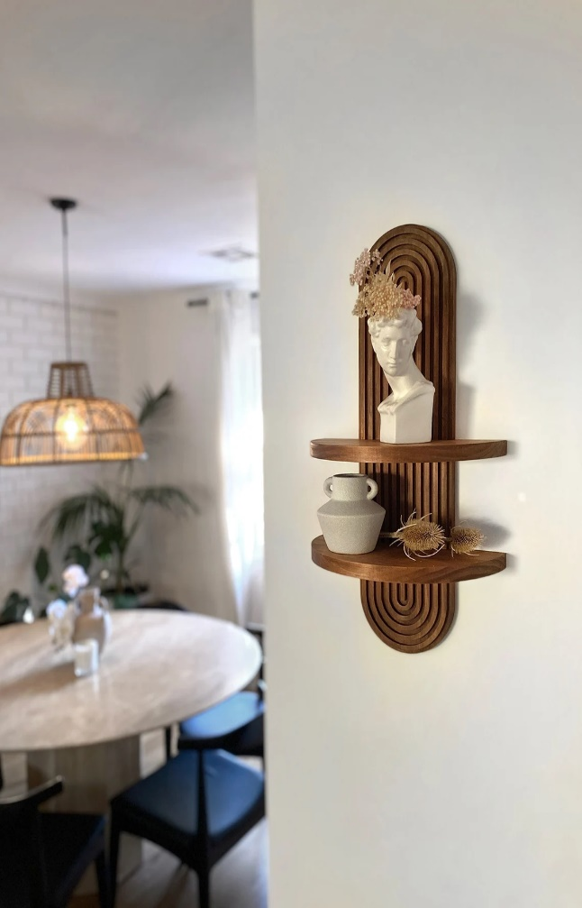 A Mid-Century Modern Wall Shelf combines sleek design with functional storage, making it a stylish addition to any contemporary home. Characterized by clean lines, minimal ornamentation, and a blend of wood and metal elements, this shelf embodies the timeless appeal of mid-century modern aesthetics. Whether made from walnut, oak, or teak, the warm wood tones are complemented by metal brackets or legs, creating a balanced and sophisticated look. Perfect for displaying books, plants, or decorative objects, a Mid-Century Modern Wall Shelf is not only practical but also enhances the overall decor of living rooms, bedrooms, or home offices with its retro yet modern charm.